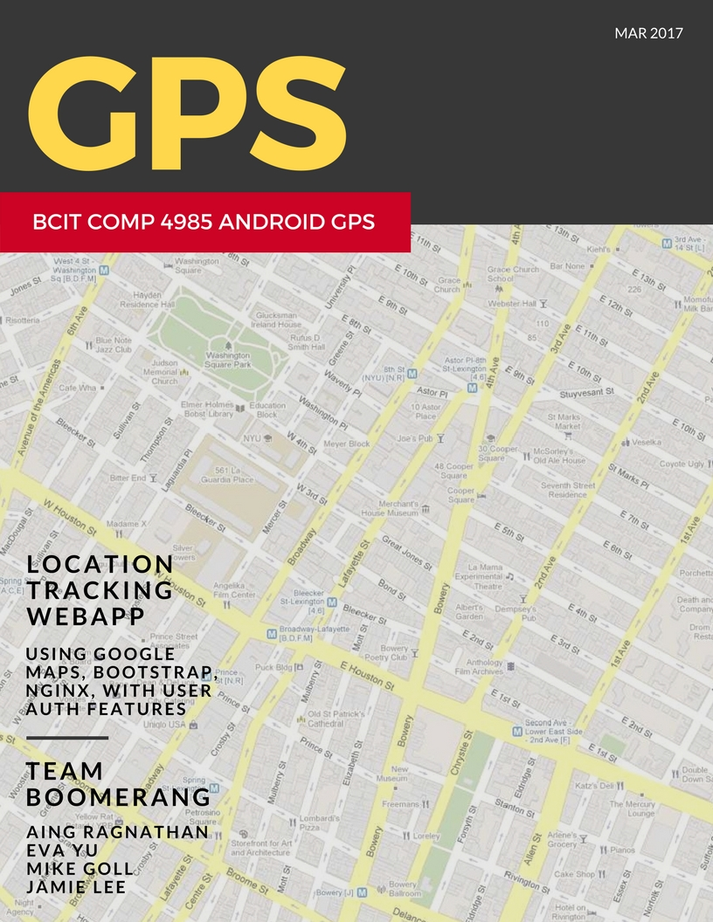

[Document title]

[Document subtitle]

[School]

[Course title]

COMP4985 A3 User Guide

# Android GPS WebApp Program

## Android GPS Client Set Up

### Equipment Requirements:

* Android Device Version 4.0 and up
* GPS reception on the device

### Instructions:

1. From your anrdroid device, go to <https://github.com/4981boomerang/androidgps> and download a copy of the **apk**
2. Go to downloads and click on the **apk**
3. Download the **apk**
4. Ensure you have gps turned on
5. Ensure you have data or wifi
6. Input your username and time sending interval

Optionally: Enter server IP and port number

1. Start the sending to server

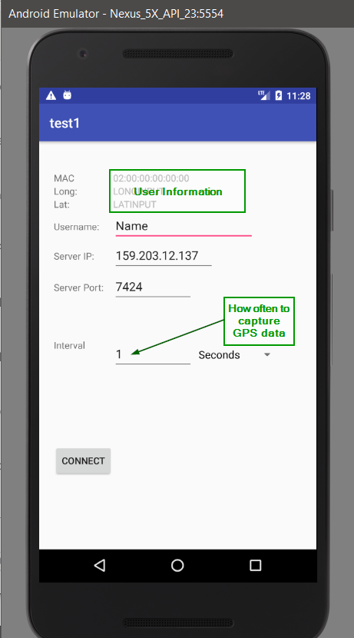

## Viewing GPS on WebApp

1. Open a browser and go to <http://159.203.12.137/>
2. Enter your username and password
3. On the left menu, click “Map”
4. You should see something like this:

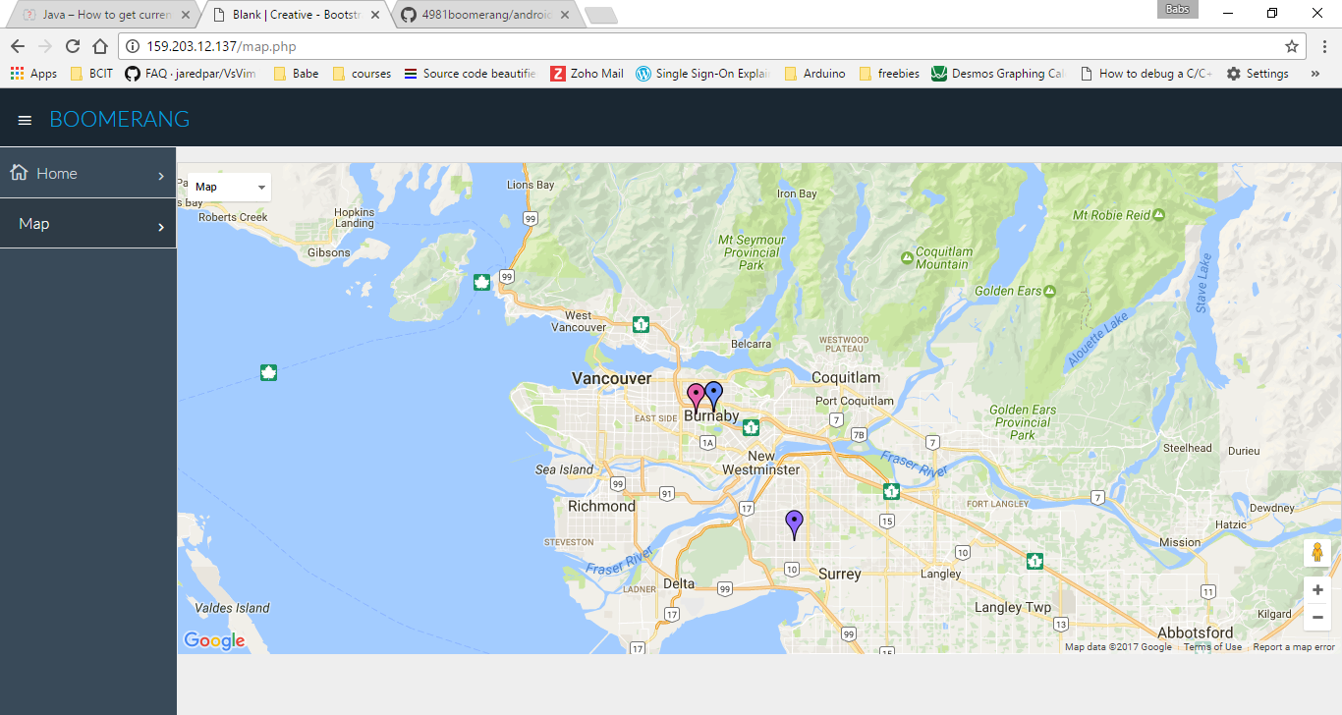

# Making A Copy of Your Own Server?

## Node GPS Server Set Up

### Software Requirements:

* JS Node v6.10.0
* **Recommended:** Linux Kernel*
* MySQL Server

**\*** Server is testedon Debian v8.7

### Instructions:

1. Install the latest stable version of Node JS   
    (A tutorial example: <https://nodejs.org/en/download/package-manager/> )
2. Install MySQL

A tutorial : <https://www.digitalocean.com/community/tutorials/how-to-install-linux-nginx-mysql-php-lemp-stack-on-debian-7>

* + Set up a table to store the data coming in with the following snippet:

CREATE TABLE gps_entry (

_id INT(6) UNSIGNED AUTO_INCREMENT PRIMARY KEY,

mac VARCHAR(17) NOT NULL,

ipaddr VARCHAR(20) DEFAULT '0.0.0.0',

username VARCHAR(32) DEFAULT 'Anonymous',

longitude DOUBLE NOT NULL,

latitude DOUBLE NOT NULL,

time DATETIME DEFAULT CURRENT_TIMESTAMP

);

1. Clone a copy of the repository from: <https://github.com/4981boomerang/androidgps>
2. Navigate to the repo’s **NodeServer** Directory
3. Run **node Server.js**

Notes:

* To test the server there is a **Client.js** that can run to be tested against server
* To run the server continuously, install pm2 with **npm install pm2**

## WebApp Set Up

### Software Requirements:

* Nginx
* Php5
* MySQL Server

### Instructions:

1. Install Nginx
2. Install PHP5
3. Install MySQL

A LEMP stack tutorial : <https://www.digitalocean.com/community/tutorials/how-to-install-linux-nginx-mysql-php-lemp-stack-on-debian-7>

* + Set up a table to store the data coming in with the following snippet:

CREATE TABLE gps_entry (

_id INT(6) UNSIGNED AUTO_INCREMENT PRIMARY KEY,

mac VARCHAR(17) NOT NULL,

ipaddr VARCHAR(20) DEFAULT '0.0.0.0',

username VARCHAR(32) DEFAULT 'Anonymous',

longitude DOUBLE NOT NULL,

latitude DOUBLE NOT NULL,

time DATETIME DEFAULT CURRENT_TIMESTAMP

);

1. Clone a copy of the repository from: <https://github.com/4981boomerang/androidgps>
2. Configure the Nginx path to direct to the repo’s **WebApp** Directory
3. On command line, type **systemctl restart nginx**
4. Go to the ip address or domain set up with nginx